Detecting COVID-19 with Chest X Ray using deep learning architecture
Mini-Project Report submitted in partial fulfillment of the requirement
for the award of degree of Bachelor of Technology

in
INFORMATION TECHNOLOGY
by

P. Sai Shivani(17WH1A1207)
Karishma Rao Namburi(17WH1A1214)

Under the esteemed guidance of
Dr. T Subetha
Assistant Professor



Department of Information Technology

BVRIT HYDERABAD College of Engineering for Women
Rajiv Gandhi Nagar, Nizampet Road, Bachupally, Hyderabad – 500090
(Affiliated to Jawaharlal Nehru Technological University Hyderabad)
(NAAC ‘A’ Grade & NBA Accredited- ECE, EEE, CSE & IT)

March, 2021

DECLARATION

We hereby declare that the work presented in this project entitled “Detecting COVID-19 with Chest X Ray using deep learning architecture” submitted towards completion of the project in IV year I sem of B.Tech IT at “BVRIT HYDERABAD College of Engineering for Women”, Hyderabad is an authentic record of our original work carried out under the esteem guidance of Dr. T Subetha, Assistant Professor, IT Department.

P. Sai Shivani
17WH1A1207

N. Karishma Rao
17WH1A1214

BVRIT HYDERABAD
College of Engineering for Women
Rajiv Gandhi Nagar, Nizampet Road, Bachupally, Hyderabad – 500090

(Affiliated to Jawaharlal Nehru Technological University Hyderabad)
(NAAC ‘A’ Grade & NBA Accredited- ECE, EEE, CSE & IT)

CERTIFICATE

This is to certify that the work entitled “Detecting COVID-19 with Chest X Ray using deep learning architecture” that is being submitted by P. Sai Shivani(17WH1A1207), N. Karishma Rao (17WH1A1214). The Mini Project Report Submitted in fulfillment of the curriculum, Bachelor of Technology in Information Technology affiliated to the JAWAHARLAL NEHRU TECHNOLOGICAL UNIVERSITY HYDERABAD is a record of bonafide work carried out by her under my guidance and supervision.

The results embodied in the project work have not been submitted to any other university or institute for the award of any degree or diploma

Internal Guide Head of the Department
Dr. T Subetha Dr. Aruna Rao S L
Assistant Professor Professor & HOD
IT Department IT Department

External Examiner

ACKNOWLEDGEMENT

We would like to express our sincere thanks to Dr. K. V. N. Sunitha, Principal, BVRIT HYDERABAD for providing the working facilities in the college.

Our sincere thanks and gratitude to Dr. Aruna Rao S L, Professor & Head, Department of IT, BVRIT HYDERABAD for all the timely support and valuable suggestions during the period of our project.

We are extremely thankful and indebted to our internal guide, Dr. T Subetha, Assitant Professor, Department of IT, BVRIT HYDERABAD for her constant guidance, encouragement and moral support throughout the project.

Finally, We would also like to thank our Project Coordinators Ms. S. Rama Devi, Associate Professor, Dr. T Subetha, Assistant Professor, all the faculty and staff of the IT Department who helped us directly or indirectly, parents and friends for their cooperation in completing the project work.

P. Sai Shivani
17WH1A1207

N. Karishma Rao
17WH1A1214

ABSTRACT
Chest X-rays are playing an important role in the testing and diagnosis of COVID-19 disease in the recent pandemic. However, due to the limited amount of labelled medical images, automated classification of these images for positive and negative cases remains the biggest challenge in their reliable use in diagnosis and disease progression. We implemented a transfer learning pipeline for classifying COVID-19 chest X-ray images from two publicly available chest X-ray datasets. The classifier effectively distinguishes inflammation in lungs due to COVID-19 and Pneumonia from the ones with no infection (normal). We have used multiple pre-trained convolutional backbones as the feature extractor and achieved an overall detection accuracy of 90%, 94.3%, and 96.8% for the ResNet50, and ResNet-18 backbones respectively. Additionally, we trained a generative adversarial framework to generate and augment the minority COVID19 class in our approach. For visual explanations and interpretation purposes, we implemented a gradient class activation mapping technique to highlight the regions of the input image that are important for predictions. Additionally, these visualizations can be used to monitor the affected lung regions during disease progression and severity stages.

V

LIST OF FIGURES

Fig.No | Diagram Description | Page number
1 | World wide distribution of covid -19 cases | 13
2 | Framework of proposed system approach | 15
3 | CNN Architecture | 16
4 | Transfer learning Process | 17
5 | Deep transfer learning | 17
6 | ResNet-18 Architecture | 18
7 | ResNet-50 Architecture | 19
8 | Model Predicted Scores | 21
9 | Class Wise model performance | 22
10 | Activation map visualization | 23

VI

LIST OF ABBREVIATIONS
CXR | chest x-ray
COVID-19 | Coronavirus Disease 2019
RT-PCR | reverse transcription polymerase chain reaction
ROC | receiver operating characteristic
P-R curve | precision-recall curve
AUC | area under the curve
GT | ground truth
FPR | false positive rate
TPR | true positive rate

VII

CONTENTS
S.NO TOPIC PAGE NO
Abstract V
List of Figures VI
List of Abbreviations VII
- Introduction

  - Covid-19
  - Chest Radiography
1.3 Problem Definition
1.4 Aim of the Project

- Literature Survey

2.1 Major Issues
2.2 Existing System
2.3 Proposed System

- System Analysis & Design

3.1 Architecture Design
3.2 Resnet-18
3.3 ResNet-50
3.4 Use Case Diagram
3.5 Sequence Diagram

- Implementation

4.1 Data Visualization
4.2 creating the model
4.3 Training the model
4.4 Results

- Conclusion

References

- INTRODUCTION

In the midst of the coronavirus disease 2019 (COVID-19) outbreak, chest X-ray (CXR) imaging is playing an important role in the diagnosis and monitoring of patients with COVID-19. Machine learning solutions have been shown to be useful for X-ray analysis and classification in a range of medical contexts.
The purpose of this study is to create and evaluate a machine learning model for diagnosis of COVID-19, and to provide a tool for searching for similar patients according to their X-ray scans. In this retrospective study, a classifier was built using a pre-trained deep learning model (ResNet18,ResNet-50) and enhanced by data augmentation and lung segmentation to detect COVID-19 in It is made available under a CC-BY-NC-ND 4.0 International license . The model was evaluated using accuracy, sensitivity, area under the curve (AUC) of receiver operating characteristic (ROC) curve and of the precision-recall (P-R) curve.

  - Covid-19

The 2019 novel Coronavirus (COVID-19) has become a serious public health issue across the world and is approaching approximately 7.759 million cases worldwide according to the statistics of the European Centre for Disease Prevention and Control on June 14th, 2020. The COVID-19infection may manifest itself as a flu-like illness potentially progressing to acute respiratory distress syndrome. Despite the worldwide research efforts over the past few months, early detection of COVID-19 remains a challenging issue due to limited resources and the amount of data available for research. The gold standard screening method for COVID19 is the Reverse-Transcription Polymerase Chain Reaction (RT-PCR).

  - Chest Radiography

Chest radiography imaging is being used as an alternative screening method and done in parallel to PCR viral testing . Additionally, false negatives have been reported in PCR results due to insufficient cellular content in the sample or time-consuming nature and inadequate detection when there were positive radiological findings .
The accuracy of Chest X-ray (CXR) diagnosis of COVID19 infection strongly relies on radiological expertise due to the complex morphological patterns of lung involvement which can change in extent and appearance over time. If these patterns are detected with high accuracy, it can enable rapid triaging for screening, diagnosis, and management of patients with suspected or known COVID-19 infection . However, the limited number of trained thoracic radiologists limits the reliable interpretation of complex chest examinations, especially in developing countries.

1.3 Problem Definition

Deep learning techniques, have been beating humans in various tasks of computer vision and other video processing tasks in recent years. Deep learning algorithms have already been applied for the detection and classification of Pneumonia and other diseases on radiography. Hence, it has become the natural candidate for the analysis of CXR images to address the automated COVID-19 screening. Some recent transfer learning approaches presented in applied to CXR images of patients has been showing promising results in the identification of COVID-19. As an effort to improve the current COVID19 detection using a limited number of publicly available CXR dataset, we devise and implement a CXR based COVID-19 disease detection and classification pipeline using a modified , ResNet-18,ResNet-50architecture. Following the trend from the literature, for our research, we have assembled a three class labelled dataset with X-ray images from ‘normal’, ‘COVID-19’, ‘Pneumonia’ classes. “COVID-19 Image Data Collection” is currently serving as the main source of COVID-19 CXR images at this stage. To enhance the under-represented COVID-19 class, we train a generative adversarial framework to generate synthetic COVID-19 images during our experiments. Our choice for the convolutional backbone for this research is mostly driven by their lightweight nature and their performance measures in terms of accuracy, precision, and recall performances to accurately detect COVID-19..
1.4 Aim of the Project

Chest radiography is widely used for the detection and classification of Pneumonia and other pulmonary diseases. In the context of COVID-19 research, a closer look at the literature showed increased use of CXR images over CT scans due to potentially more data available from various sources. However, accurate annotation and analysis of radiography images require a radiology expert which requires significant expertise and processing time. To identify underlying features from radiography images for the purpose of diagnostic analysis, a series of recent studies showed promising results using state-of-the-art computational and deep learning algorithms .The current literature on COVID-19 CXR image analysis using deep learning methods.
Design insights are derived from the review of the related work and we describes the dataset for the implemented network. The influence of model backbones on the training time, loss, and model accuracy. We also present a gradient class activation mapping (Grad-CAM) technique to monitor affected lung regions during disease progression for visual interpretation purposes.
Here, we train ResNet18 and ResNet50 on COVID-Xray-5k dataset, and analyze their performance for COVID-19 detection. Since so far there is a limited number of X-ray images publicly available for the COVID19 class, we cannot simply train these models from scratch. Two strategies were adopted to address the COVID-19 image scarcity issue in this work, we use data augmentation to create transformed version of COVID-19 images (such as flipping, small rotation, adding small amount of distortions), to increase the number of samples by a factor instead of training these models from scratch, we fine-tune the last layer of the pre-trained version of these models on ImageNet. In this way, the model can be trained with less labeled samples from each class.

2.Literature Survey
2.1 Major issue
Coronavirus outbreak and spreading across the world since December 2019, and has become common in a variety of countries. Planning and actions from the government.
Response to the pandemic varied from country to country, and their role in impacting disease transmission was addressed. Machine learning methods have been carried out to identify and detect COVID-19 disease from the last few months.

Some of these are as follows:
Fei et al. proposed a “VB-Net” deep learning system for automated segmentation of all lung and infection sites using CT in the chest . A chest scan with computed tomography (CT) is one of the good methods used for the treatment of pneumonia. Automatic COVID-19 CT image analysis tools using artificial intelligence methods can be used to identify, measure, and monitor coronavirus disease. It helps to differentiate coronavirus patients from healthy people. To discriminate COVID-19 pneumonia and Influenza-A viral pneumonia from disease-free people. Discovered an early screening model. This model is based on pulmonary CT images and deep learning techniques. It gives 86.7% maximum overall accuracy using deep learning CNN model.
Shuai et al. developed a deep learning method that can extract COVID-19’s graphical characteristics. They analyzed COVID-19 radiographic changes from CT images. This method is used to provide clinical conclusions before pathogenic testing and in this way, we can save critical time for the disease diagnosis.They obtained 89.5% accuracy with 88.0% precision and 87.0% sensitivity. They introduced an approach for the identification of COVID-19 based on deep feature and SVM using Xray images. They extracted the deep feature of CNN models and fed them to the SVM classifier individually. It results in 95.38% accuracy for ResNet-50 and SVM. COVID-19 cousins are represented as MERS-CoV and SARS-CoV.
Ahmet Hamimi’s analysed MERS-CoV and demonstrated (a).Worldwide distribution of COVID-19 cases (b). Total number of COVID-19 casess Fig. 1

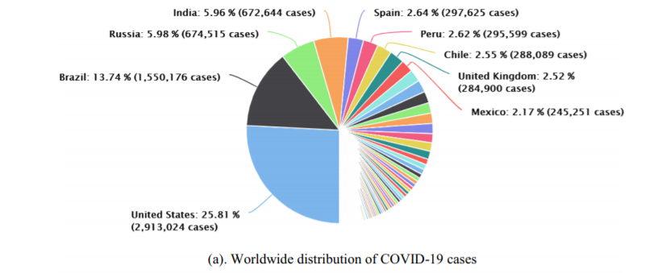
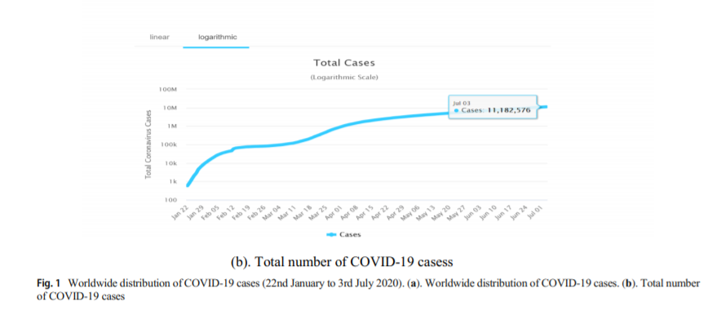
2.2 Existing System
To limit the transmission of COVID-19, screening large number of suspicious cases is needed, followed by proper medication and quarantine. RT-PCR testing is considered to be the gold standard grade of testing, yet with significant false negative outcomes. Efficient and rapid analytical techniques are earnestly anticipated to fight the disease. In view of COVID-19 radio graphical differences in CT images, we propose to develop a deep learning model that would mine the unique features of COVID-19 to give a clinical determination in front of the pathological test, thereby sparing crucial time for sickness control.
Understanding the basic idea of COVID-19 and its subtypes, varieties might be a continual test, and the same should be made and shared all over the world. Baidu Research discharge its LinearFold calculation and administrations, which can be utilized for whole genome optional structure forecasts on COVID-19, and is evidently multiple times quicker than different calculations.

2.3 Proposed System

The proposed method is inspired by a statistical analysis of the potential imaging biomarkers of the CXR radiographs. The main focus of this paper is to develop a neural network architecture that is suitable for training with limited training data set, which can still produce radiologically interpretable results. Sarkodie et al. showed a report which focuses on the role of chest X-ray in the diagnosis of the disease .
Chest X-ray can be used as an effective, fast, and affordable way to immediately triage COVID-19 patients when suspected and should be encouraged as a diagnostic tool for isolation until PCR testing is done for confirmation. Abdul et al. present a method to generate synthetic chest Xray (CXR) images by developing an Auxiliary Classifier called
ResNet-18 and ResNet-50 . They concentrated on the unavailability of a significant number of radiographic images. In addition, they demonstrated that the synthetic images produced from ResNet-18 and ResNet-50 can be utilized to enhance the performance of CNN for COVID-19 detection.
Classification using CNN alone yielded 85% accuracy. By adding synthetic images produced by ResNet-18 and ResNet-50, the accuracy increased to 95% . So, inspired by this early success, in these papers we aim to further investigate deep convolutional neural network and evaluate its feasibility for COVID-19 diagnosis.
The motivation behind this exploration is to evaluate the performance of available convolutional neural networks introduced by researchers, related to the automatic diagnosis of COVID-19 from thoracic X-rays.
Additionally, the motivation behind this S. Hira et al. investigation is to determine the practicality of top-tier predesigned convolutionary neural frameworks which is discovered by knowledgeable researchers. Since the pandemic is recent, there are only a limited number of CXR images available for study. The lack of data in medical imaging led us to explore ways of expanding image datasets. To solve the limitations of the current study, we are focusing on improvements in COVID-19 detection. For evaluation, we also used a dataset provided by the author . The dataset consist of an aggregate of 5232 images, where normal category has 1346 images, 3883 images delineated pneumonia, out of which 2538 images have a place with bacterial pneumonia and 1345 images delineated viral pneumonia.

3.System Analysis & Design

3.1 Architecture Design

Recently, CNN architecture based deep learning models used to solve computer vision problems. We used deep CNN architecture based ResNet-18 and ResNet-50 models coupled with transfer learning techniques to classify COVID-19 Chest X-ray image data between normal and COVID- 19 patient. Transfer learning also helps to deal with inadequate data and model execution time.The schematic illustration of used CNN architectures along with pre-trained ResNet-18 and ResNet-50 models

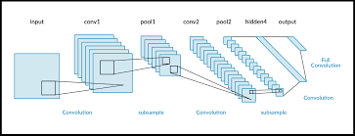

3.1 ResNet-18
Resnet 18 is image classification model pretrained on ImageNet dataset. This is PyTorch implementation based on architecture described in paper "Deep Residual Learning for Image Recognition" in Torch Vision package.The model input is a blob that consists of a single image of "1x3x224x224" in RGB order.The model output is typical object classifier for the 1000 different classifications matching with those in the ImageNet database.
ResNet-18 is a convolutional neural network that is 18 layers deep. You can load a pretrained version of the network trained on more than a million images from the ImageNet database.

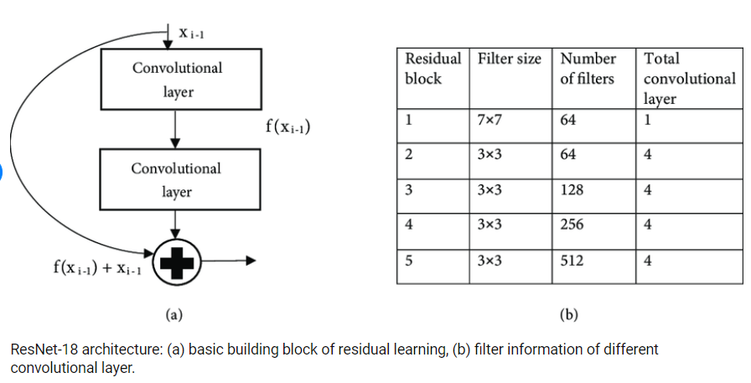

3.2 ResNet-50

To simplify the training task of deep networks a new architecture comes with a residual learning framework known as ResNet. In this architecture network layers are reformulated by learning using residual functions in respect of layer inputs. ResNet is also called a residual network that introduces skip connection concept to deal vanishing gradient problem. This prevents the distortion which appears as the network becomes deeper and complex. ResNet variant ResNet-50 is used as one of the models. ResNet-50 architecture is shown in Fig. 9. This makes use of a 50-layer network and trained using ImageNet dataset. The ResNet-50 architecture evolves convolutional layer, 4 convolutional blocks, max pool, and average pool to address the degradation of the accuracy. This helps to generate deeper CNNs by maintaining accuracy. The ResNet-50 architecture provided a way for developers to build even deeper CNNs without compromising accuracy. ResNet-50 was among the first CNNs which make use of Fig. 4 Transfer learning process batch normalization feature.

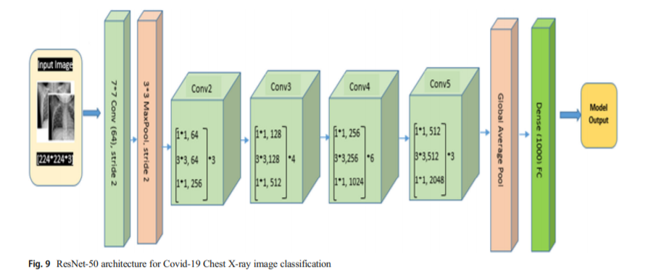

3.3 Use case Diagaram:

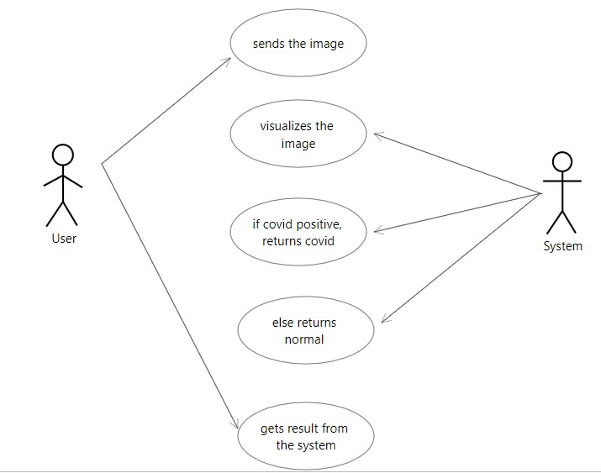

3.4 Sequence Diagram:

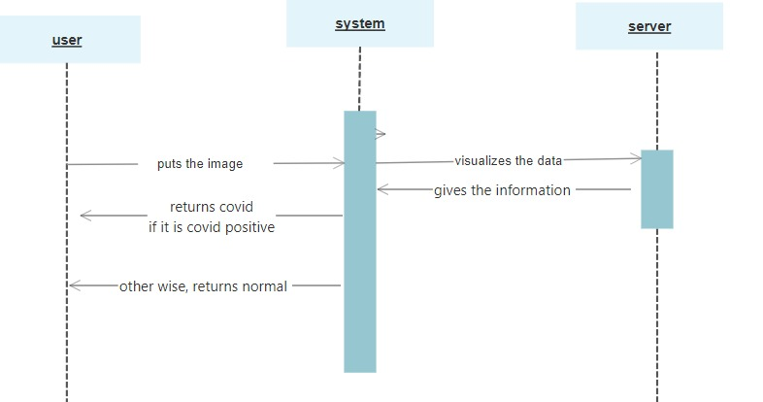

3.Implementation
3.1 Data visualization

Some group of Chest X-ray image data is collected images belong to common bacterial-pneumonia in our dataset,for training purposes of the model to differentiate between COVID-19 patients and common pneumonia patients.This group of a dataset is collected from the website hosted.
We refer to this group of images as Dataset1and Dataset2. Dataset1 includes only two categories of images as confirmed COVID-19: 224 and normal or healthy condition: 504.Dataset2 includes three categories of images as confirmedCOVID-19: 224, confirmed common bacterial pneumonia normal condition.
The code development and analysis was performed by six of the authors who are not radiologists(Y.E., D.K., D.Y., Y.S., E.G., A.B.). The clinical images were collected and approved(L.C., E.A., L.L, D.L., Z.N., M.M., M.H., N.E., E.S., B.N.G, S.T., Y.R., D.S., A.D., N.R.B., A.G., N.S.),who are employed as physicians of multiple disciplines including radiologists in the hospitals which provided the data.
This study includes CXR images from 1384 patients, 360 with a positive COVID-19 diagnosisand 1024 negative, totaling 2427 CXRs. Patients’ COVID-19 labels were determined by acombination of RT-PCR testing and clinical assessment by the physicians. The COVID-19positive images include all CXRs performed with portable X-ray machines on patients admitted.
to four hospitals in Israel during the pandemic’s first wave (December 2019 through April 2020). For the control dataset we obtained CXRs taken by the same X-ray machines prior to December 2019.
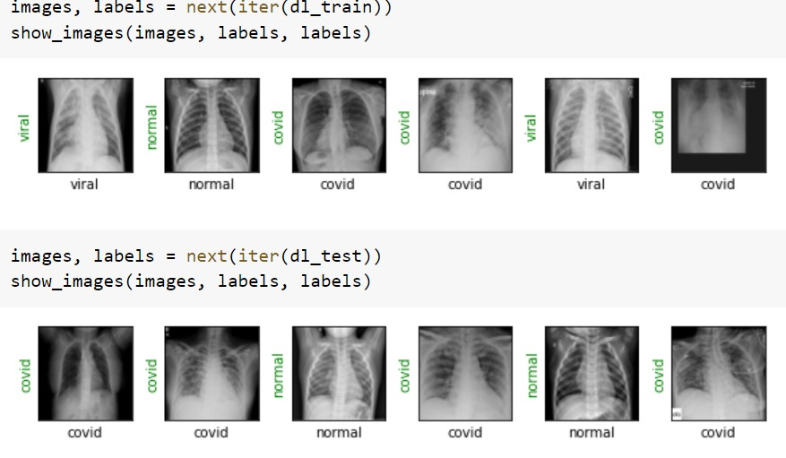
3.2Creating the model:

Resnet models were proposed in “Deep Residual Learning for Image Recognition”.
Here we have the 5 versions of resnet models, which contains 5, 34, 50, 101, 152 layers respectively.
All pre-trained models expect input images normalized in the same way, i.e. mini-batches of 3-channel RGB images of shape (3 x H x W), where H and W are expected to be at least 224. The images have to be loaded in to a range of [0, 1] and then normalized using mean = [0.485, 0.456, 0.406] and std = [0.229, 0.224, 0.225].
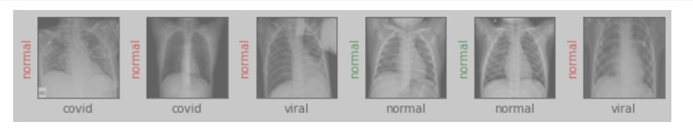

3.3Training the model :

The general approach of these architectures is to reduce images from a high-dimensional to a low-dimensional space such that a simple boundary can be used separate image classes. The models were trained using transfer learning, i.e. using pre-trained
weights and subsequently retraining them on our data The best test accuracy scores were
achieved after 32 epochs. The models were built and trained using Pytorch 1.6;
In addition to classification, we propose a method for retrieving a number of CXR images thatare the most similar to a given image. The activation of layers of the neural network serve as embeddings of the images into a vector space, and should capture information about clinical indications observed in the images. We use these embeddings to search for similarity between the resulting vectors, and retrieve the nearest neighbors of each image.

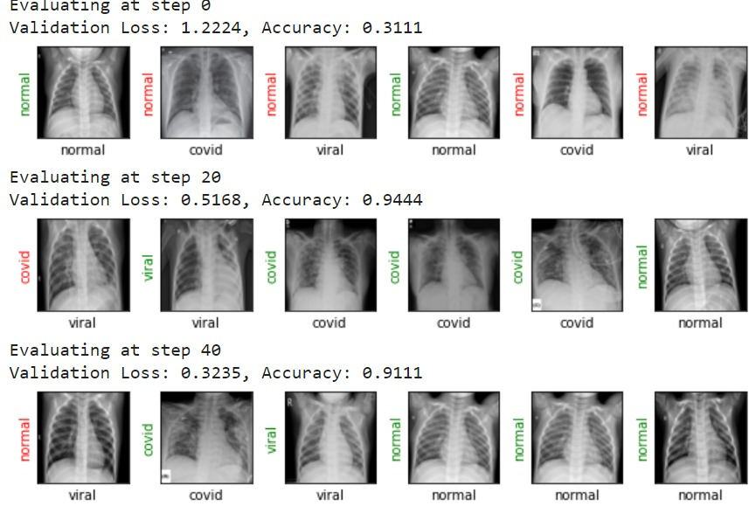

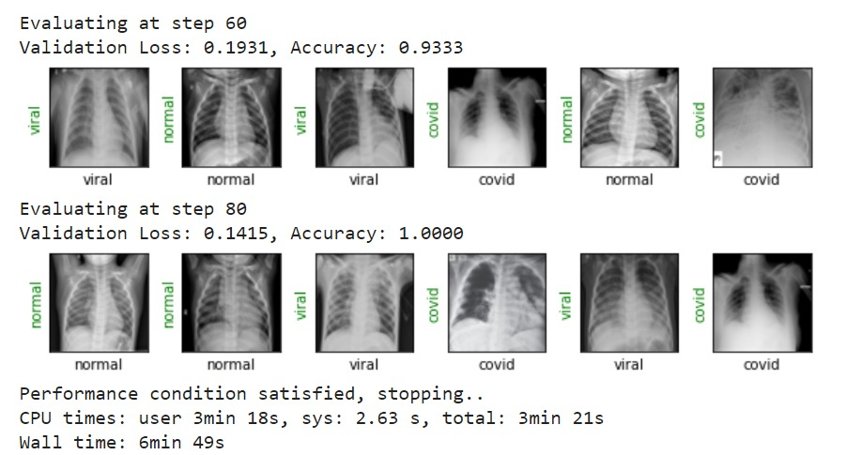

3.4 Results

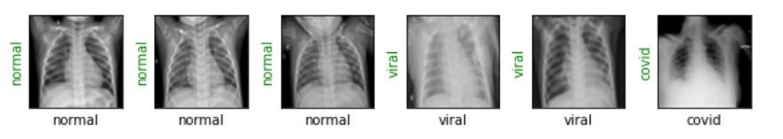

4.CONCLUSION

Early diagnosis of COVID-19 patients is important for preventing the disease from spreading to others. In this paper, we introduced a deep CNN based approach using transfer learning to differentiate COVID-19 patients from bacterial pneumonia, viral pneumonia, and normal. We have deployed nine pre-trained CNN models to explore the transfer learning techniques and conclude that fine tuning the pre-trained CNN models can be successfully deployed to a limited class dataset.CT imaging is an important method for diagnosing and assessing COVID-19. We have used pre-trained expertise to improve COVID-19’s diagnostic efficiency. The proposed system produced a maximum accuracy of 99.32% for binary class and 97.55% for multi-class among all the seven models. Our high accuracy findings can be helpful to the doctors and researchers to make decisions in clinical practice. Our study has several limitations that can be overcome in future research. In particular, a more in-depth analysis requires much more patient data, especially those suffering from COVID-19. A more interesting approach for future research would focus on distinguishing patients showing mild symptoms, rather than pneumonia symptoms, while these symptoms may not be accurately visualized on X-rays, or may not be visualized at all. Furthermore, we will try to use our approach on bigger datasets, to solve other medical problems like cancer, tumors, etc. and also on other computer vision fields as energy, agriculture, and transport in the upcoming days. Future research directions will include the exploration of image data augmentation techniques to improve accuracy even more while avoiding overfitting. We observed that performance could be improved further, by increasing dataset size, using a data augmentation approach, and using hand-crafted features, in the future

References

1. Tensorflow lite for mobile and embedded learning (2019). https:// www.tensorflow.org/lite/microcontrollers/overview
2. Abbas A, Abdelsamea MM, Gaber MM (2020) Classification of covid-19 in chest x-ray images using detrac deep convolutional neural network. arXiv:2003.13815
3. Araujo-Filho JdAB, Sawamura MVY, Costa AN, Cerri GG, Nomura CH (2020) Covid-19 pneumonia: what is the role of imaging in diagnosis? J Brasileiro Pneumol 46(2)
4. Butt C, Gill J, Chun D, Babu BA (2020) Deep learning system to screen coronavirus disease 2019 pneumonia. Appl Intell:1
5. Chollet F (2018) Introduction to keras
6. Chowdhury ME et al (2020) Can AI, help in screening viral and covid-19 pneumonia? arXiv:2003.13145
7. Cohen JP, Morrison P, Dao L (2020) Covid-19 image data collection. arXiv:2003.11597
8. Farooq M, Hafeez A (2020) Covid-resnet: A deep learning framework for screening of covid19 from radiographs. arXiv:2003.14395

